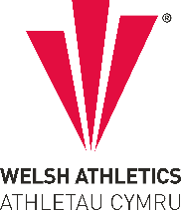
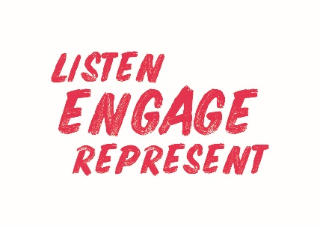
Welsh Athletics Endurance Officials Meeting Minutes
Held on the Monday 7 August 2023
Meeting held remotely via video link

Present: Nigel Jones (Chair) Christine Vorres, Jacqueline Brace, Alex Donald. Zoe Holloway. Paul Brooks,
Apologies:
Danielle Phillips

Actions from meeting
Item Number | ACTIONS | Person responsible
3a | Nigel to feedback response from James Williams regarding his request for Officials expenses to be increased by 5p a mile minimum | Nigel
3a | Zoe to create an ‘Expression of interest’ form to be sent to officials needing to complete a Risk Awareness course | ZH & CV
3a | Christine to email the 12 officials that need to complete the Risk Awareness course in about 2 weeks to remind them.

- Declaration of Interest – None declared
3. Decisions
a) Matters arising from previous meeting:-
- Nigel has written to James to ask for increase in expenses paid to Officials.
- Zoe fed back that there is very little appetite for the Risk Awareness course at the moment – probably due to holidays. 5 – 6 attendees are required to make the on-line course viable. Maybe ask parkrun volunteers if they would like to attend a course too.
- Discussion
4a – Run Britain
Chris Moss is the project lead for the transfer of Run Britain to Welsh Athletics. Jacqueline expressed concerns that it will not realistically be ready in 4 weeks, and many events have already registered on Run Britain. There was a discussion about the functionality of the Run Britain site now that Gavin has left. Jacqueline also advised the members that a series of races, if they are all the same does not need to have an adjudicator present at each event in the series, although it is desirable to have one. This may be why some events have not had forms sent out by Run Britain. Alex confirmed the new Welsh Athletics site may not be ready for a few months as the biggest thing is the consultation that Chris Moss is working on at the moment.
4b – Officials availability forms
Alex will send out forms for pre-christmas events, then another one for post-christmas events.

- Correspondence – None

- AOB:

6a – Officials
Zoe updated the members with further details of the plans for WA to oversee the management of level 1 – 3 Officials. WA will be responsible for the education of Officials, but there will be no real difference to Officials themselves, other than a new set of Terms and Conditions that each will need to sign up to. These will be in their portals and an email will be sent out soon with full details. Level 4 – 5 Officials will still be licensed with UKA
Zoe presented graphs of the numbers of officials over a number of years, and with a breakdown of each area. No level 4 Officials in the East region. The facts help to identify those who may want to progress, and WA are looking at ways to simplify the progression process.
6b – Awards Dinner
The award categories have been announced, and Zoe urged members to put forward nominations for the Endurance officials.
The meeting ended at 7.10pm .
Date of Next meetings:
10th October
4th December
Minutes written by Chris Vorrés. 7 August 2023

